**Ryde Mead Tennis Club**

**OPEN DAY**

**WITH THE OFFICIAL OPENING OF OUR NEW CLUBHOUSE**

**SATURDAY 14TH May**

**Play Tennis For Free**

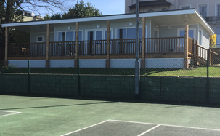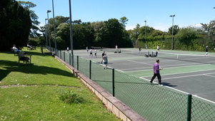

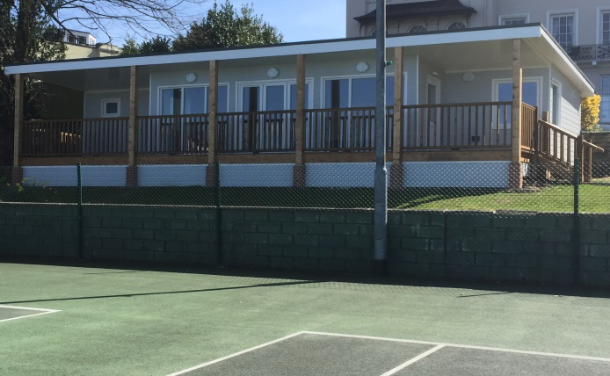On Saturday 14th May, Ryde Mead Tennis Club will officially opening its brand new clubhouse to the community. To celebrate, the club is opening its doors and offering free tennis as part of the Lawn Tennis Association Great British Tennis Weekend.

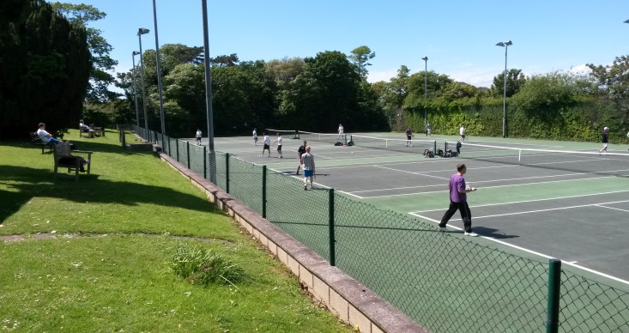Members of the community are invited and to celebrate the club we will be organising a programme of **free tennis** and coaching sessions for people of all ages and abilities throughout the day. All equipment provided.

The programme of sessions throughout the day will include

Places limited so please book on Tel 616040 or email [rydemeadtennis@outlook.com](mailto:rydemeadtennis@outlook.com)

9.00am – 9.45am Mini Tennis 5 – 8yrs

9.45am - 10.30am        Mini Tennis 5 – 8 yrs

10.30am - 11.30pm Junior Tennis 11 -16yrs

11.30pm - 12.30pm Adults

12.30pm - 3.00pm Family Tennis

Join the club on the day and receive 20% discount on annual membership

Wilson rackets on sale at discounted prices





Supported by [](http://www.bing.com/images/search?q=wilson+logo&id=62B0E35570E63020E65933E1F02258E674E1C02B&FORM=IQFRBA)