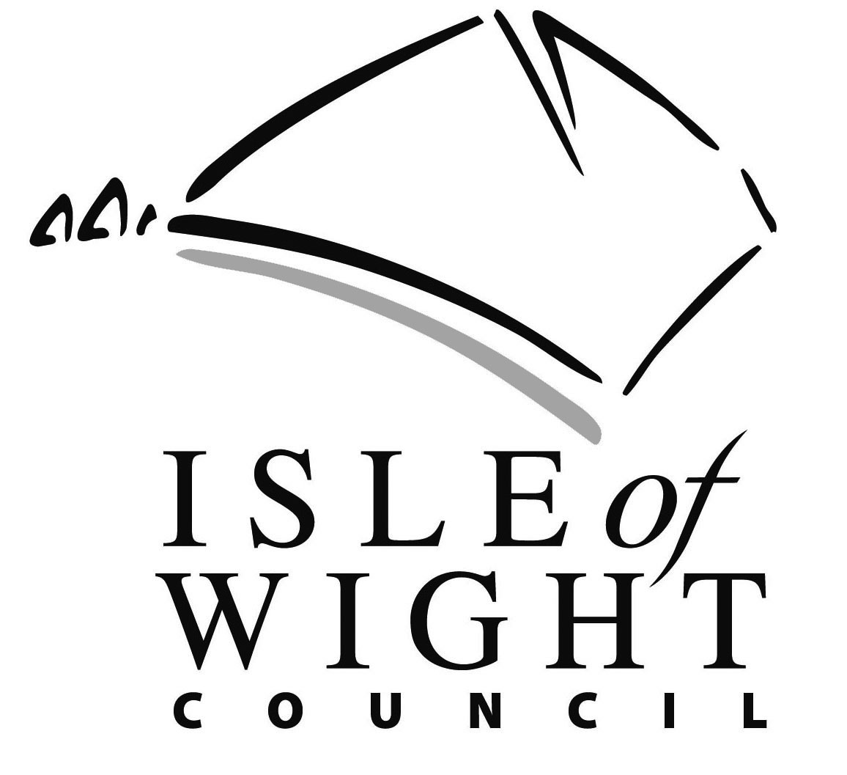

Isle of Wight Council Equality Monitoring Form

The Isle of Wight Council want to make sure that we are an equal opportunities employer in practice, which is why we want to monitor the diversity of people applying to work with us.

This form does not form part of the selection process and is separated from your application form whilst consideration of candidates takes place. Information provided will be treated as confidential and doesn’t form part of the selection process.
Post Title: | Post Ref No:
Department: | National Insurance Number:
Last name: | First name:
What age group do you belong to?
<25 25-34 35-44 45-54 55-64 65+

1. Do you consider that you have a disability?
Yes
No

2. Sex (Gender)
Male
Female

3. How would you describe your ethnic origin?
1 | White British
2 | Irish
3 | Any other White background (please specify)
4 | White and Black Caribbean
5 | White and Black African
6 | White and Asian
7 | Any other Mixed Race background (please specify)
8 | Asian British
9 | Indian
10 | Pakistani
11 | Bangladeshi
12 | Any other Asian background (please specify)
13 | Black British
14 | Black Caribbean
15 | Black African
16 | Any other Black background (please specify)
17 | Chinese
18 | Any other ethnic group not classified above (please specify)
4. Are you married or in a civil partnership?
Married Yes Civil Partnership Yes
Married No Civil Partnership No
5. How would you describe your sexuality?
Heterosexual/straight
Gay man
Gay woman/lesbian
Bisexual

6. Have you undertaken or are you undertaking gender reassignment?
Yes
No

How would you describe your religion / belief?
My religion or belief is ………………………………
I have no religion or belief

Data Protection
The information given may be processed by computer for purposes registered by the Council under data protection legislation. Individuals have the right of access to computerised personnel data concerning them.

Thank you for your co-operation.

Date: / /

